Zachary Frye
CSC 500
Module 3 Assignment
2/1/2026
Pseudocode:
Part 1:
- Start
- Prompt user to enter subtotal
- Store the subtotal and round to two digits
- Calculate the tip and store, round
- Calculate the total and store, round
- Print the tip amount
- Print the sales tax amount
- Print the overall total
- Stop
Part 2:
- Start
- Prompt the user for the current time
- Store the current time
- Mod the current time input by 24 to avoid numbers out of range
- Prompt user for number of hours for alarm
- Store number of hours
- Print the calculation for the alarm’s time
  - Take currentTime + hours and mod by 24 to get the proper time on the 24-hour scale
  - Use fstring to properly embed the value with the string
- Stop
#Zachary Frye
#CSC 500
#Module 3 Assignment
#Part 1

print('Please enter the subtotal for the order:') #prompts the user for the subtotal
subtotal = round(float(input()),2) #gets input from the user and rounds to two decimal places
tip = round((subtotal * 0.18),2) #calculates the tip amount and rounds to two decimal places
tax = round((subtotal*0.07),2) #calculates the sales tax amount and rounds to two decimal places
total = round((subtotal + tip + tax),2) #calculates the overall total by adding the three variables together, rounds to 2 decimal places
print('The tip amount is: $', tip) #prints the tip amount
print('The sales tax is: $', tax) #prints the sales tax amount
print('The overall total for this order is: $', total) #prints the overall total of the meal

#Zachary Frye
#CSC 500
#Module 3 Assignment
#Part 2

print('What is the current time? (in hours, use 0 to 23)') #prompts the user for the current time in hours
currentTime = int(input()) % 24 #get current time from user, mod 24 to prevent numbers outside of range
print('In how many hours will this alarm go off?') #prompts the user for number of hours until alarm goes off
hours = int(input()) #gets number of hours from input
print(f"The time when this alarm goes off will be: {(currentTime + hours) % 24}:00") #prints the calculation for the new time, uses fstring to remove the space after the variable calculation

Results:
Part 1:
Please enter the subtotal for the order:
67
The tip amount is: $ 12.06
The sales tax is: $ 4.69
The overall total for this order is: $ 83.75

Part 2:
What is the current time? (in hours, use 0 to 23)
7
In how many hours will this alarm go off?
19
The time when this alarm goes off will be: 2:00

Screenshots:
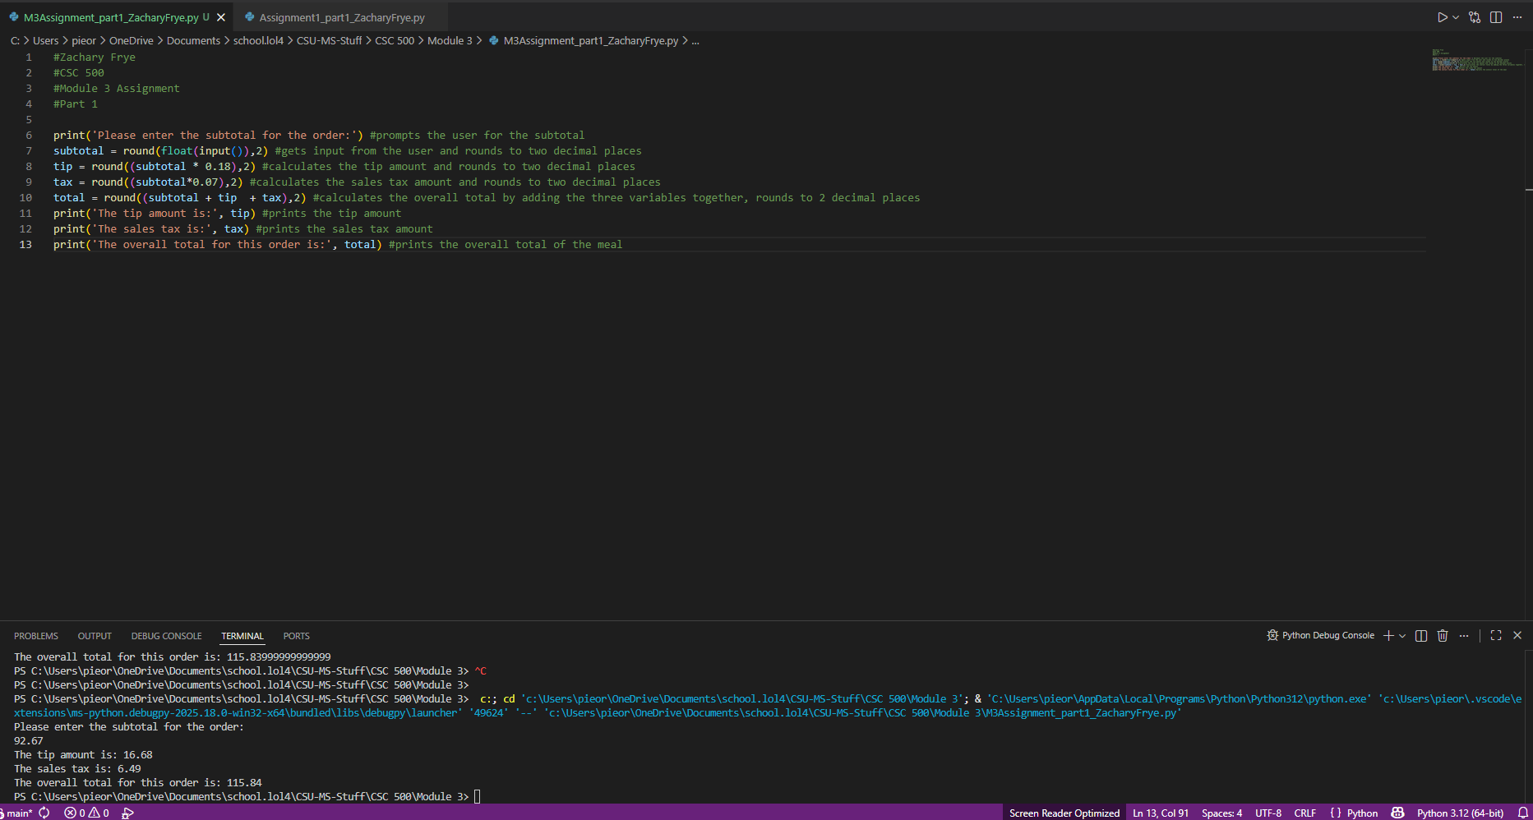
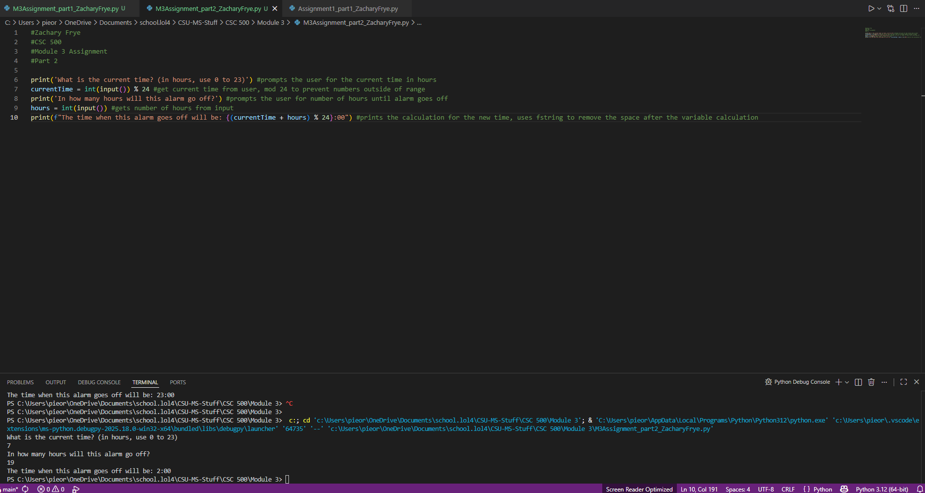
GitHub repository link

